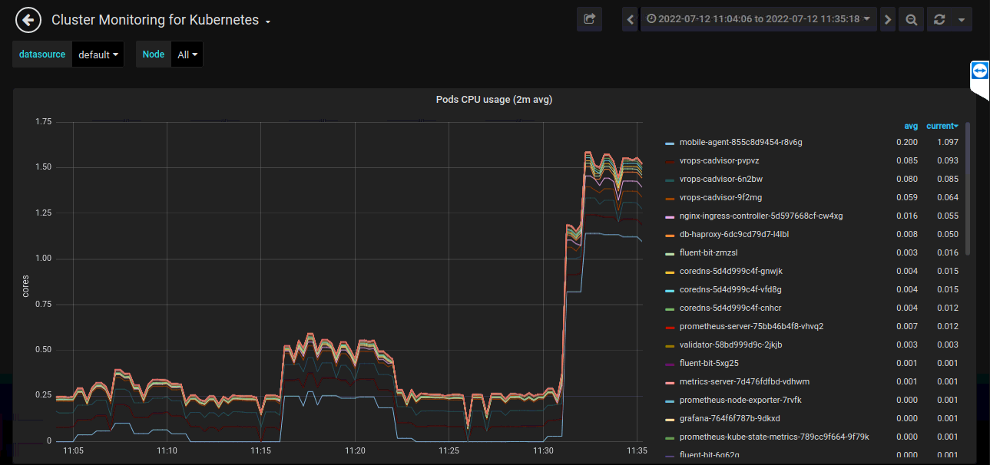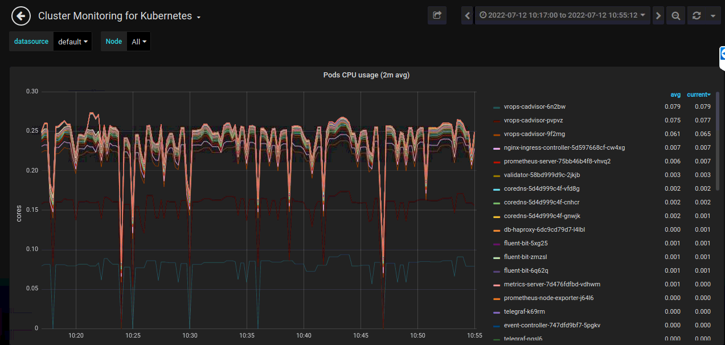

TC 4 used 0.28 core of the current CPU usage, equivalent to 1.167%., TC5 used 0.53 core of the current CPU usage, equivalent to 2.208%. and TC 6 used 1.53 core of the current CPU usage, equivalent to 6.375%.

TC 1,2 and 3 used 0.27 core of the current CPU usage, equivalent to 1.0417%.

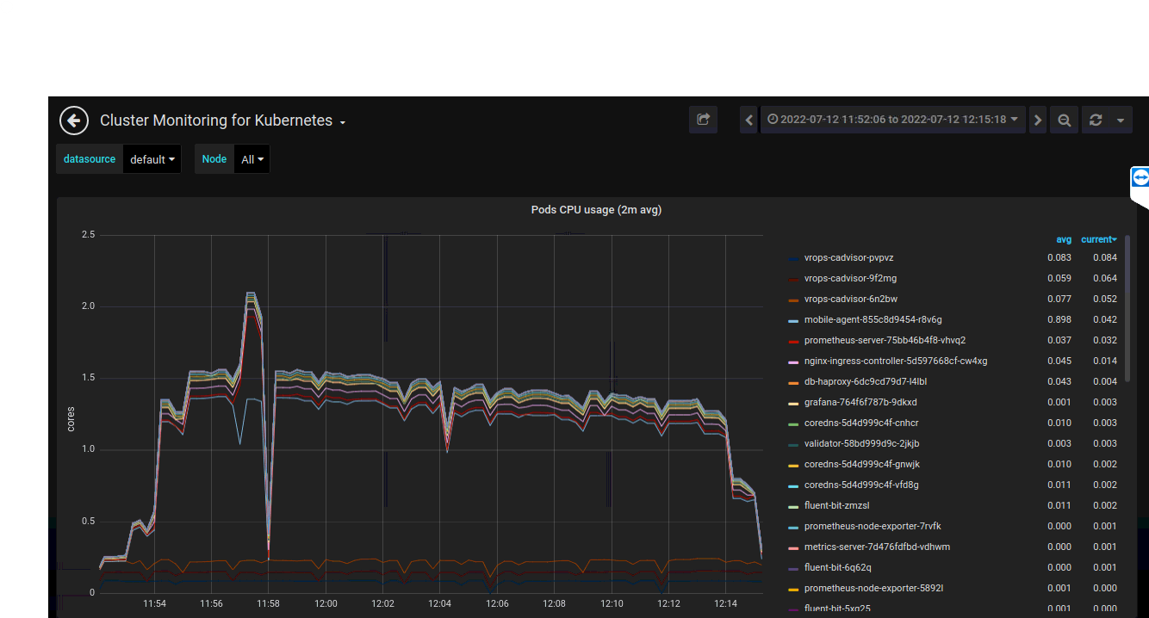

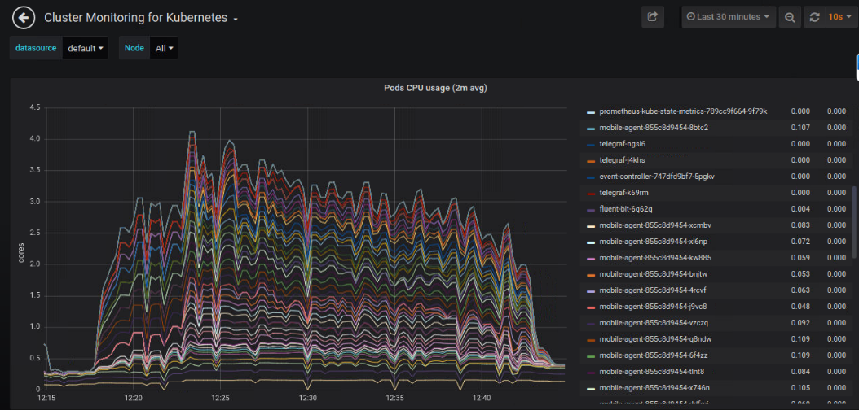

TC8 used 4.2 core of the current CPU usage, equivalent to 17.5%.

TC7 used 2.2 core of the current CPU usage, equivalent to 9.167%.

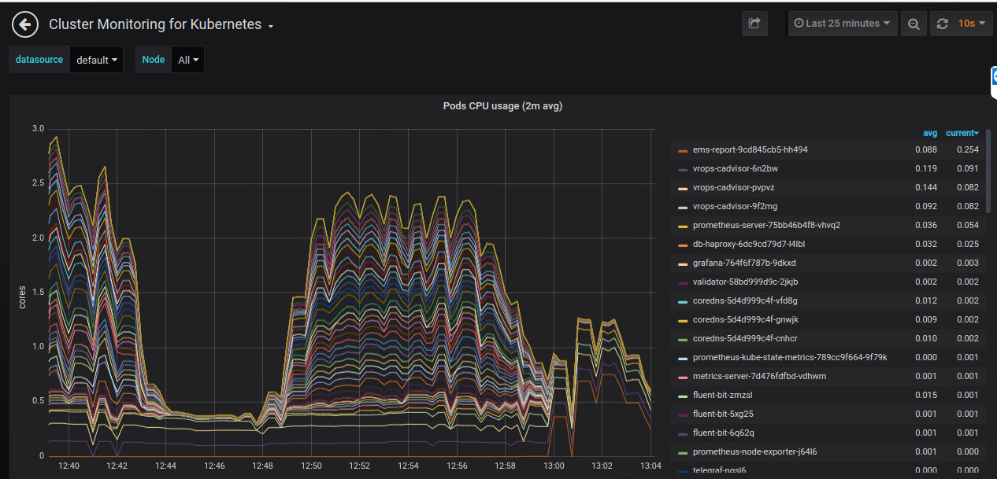

TC9 used 2.4 core of the current CPU usage, equivalent to 10%.

TC 10 used 1.55 core of the current CPU usage, equivalent to 6.458%.

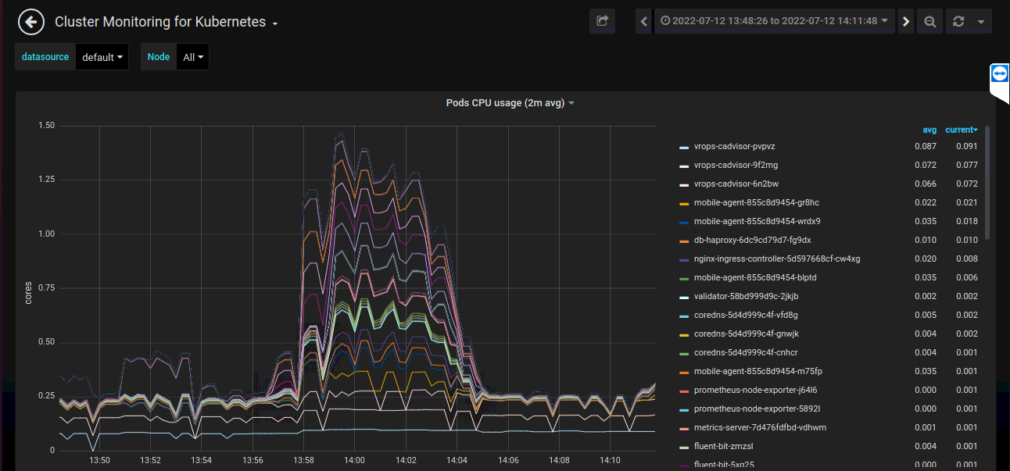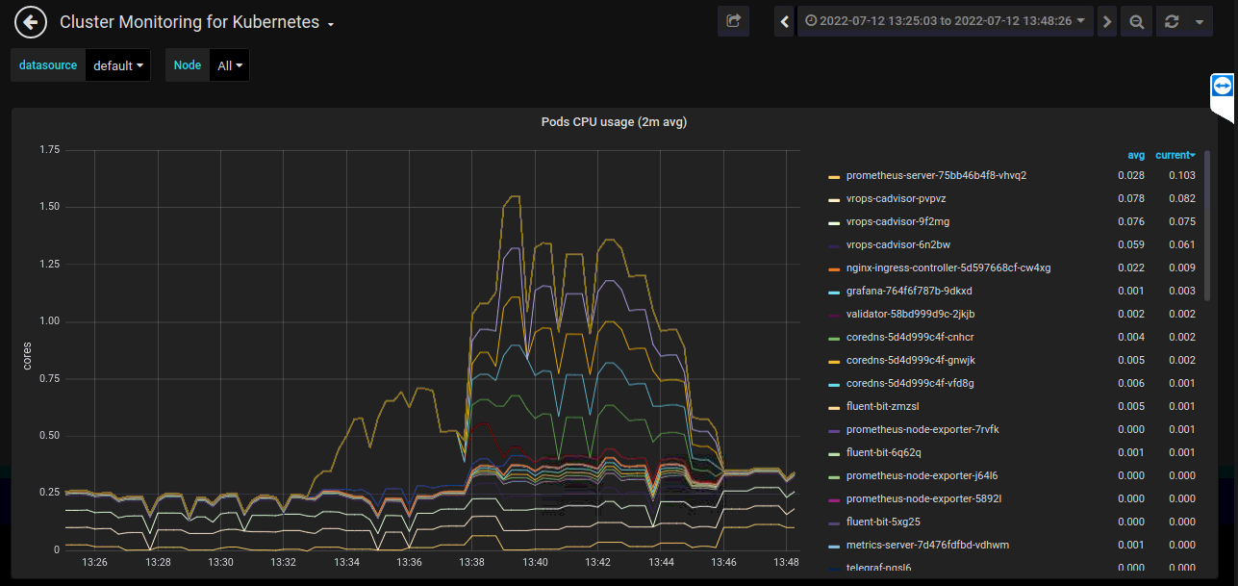

TC 11 used 1.55 core of the current CPU usage, equivalent to 6.458%.

TC 12 used 1.48 core of the current CPU usage, equivalent to 6.167%.

TC 13 used 1.2 core of the current CPU usage, equivalent to 5%.

TC 14 used 0.88 core of the current CPU usage, equivalent to 3.67%.

TC 6 used 10.8GB (11.25%) out of 96GB of memory.

TC1 until TC 5 remain the same usage which are 1.98GB(2.06%) out of 96GB of memory, TC 6 used 2.78GB(2.9%) out of 96GB of memory, and TC 7 used 3.2GB(3.33%) out of 96GB of memory.

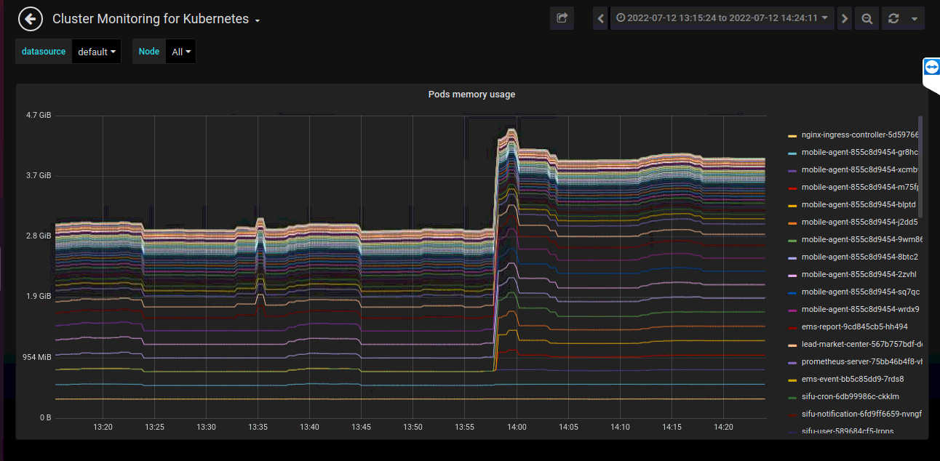

TC 10 and 11 used 2.9GB (3.021%) out of 96GB of memory. TC 12 used 4.5GB (4.69%), TC13 and TC14 used 3.89GB(4.05%) out of 96GB of memory.

TC9 used 8.9GB(9.27%) out of 96GB of memory.